Online auction and bidding system
Abstract :
The Online Auction and Bidding System is a robust, console-based Java application designed to simulate, automate, and manage digital auction workflows. Developed using advanced programming paradigms, the system handles item registration, dynamic real-time bidding with strict validation rules, rapid item searching, and comprehensive data analytics. It integrates core and advanced Java features—including object-oriented modeling, custom exception handling for business logic enforcement, persistent file storage using modern java.nio.file APIs, the Collections Framework (ArrayList, HashMap, HashSet), and declarative processing via Java Stream API pipelines. The project demonstrates an end-to-end scalable software solution combining security, maintainability, and efficiency.
Advantages :
- Robust Data Validation & Error Handling: Implements custom exceptions (such as InvalidBidException) to intercept rule violations—preventing bids lower than current highest offers or transactions on closed items—thereby ensuring application stability and secure operations.
- Persistent Data Storage: Utilizes modern Java java.nio.file (Files and Path) APIs alongside stream readers and writers to automatically persist and retrieve catalog data across application executions, preventing data loss.
- Optimized Data Retrieval: Combines Hash-based directory mapping (HashMap) for instant O(1) item lookups with sorted arrays and binary search algorithms for efficient verification and searching.
- Declarative Analytics & Reporting: Leverages the Java Stream API, lambda expressions, and Collectors (groupingBy, counting) to perform real-time filtering of high-value items and category-wise reporting without writing repetitive imperative loops.
- Modular and Object-Oriented Architecture: Strictly adheres to object-oriented design principles (encapsulation, parameterized constructors, comparable sorting interfaces, and modular utility classes), making the codebase easy to maintain, extend, and scale.
Code:
import java.io.IOException;
import java.nio.file.Files;
import java.nio.file.Path;
import java.nio.file.Paths;
import java.nio.file.StandardOpenOption;
import java.util.*;
import java.util.stream.Collectors;

// ==========================================
// MODULE 4: Custom Exception
// ==========================================
class InvalidBidException extends Exception {
public InvalidBidException(String message) {
super(message);
}
}

// ==========================================
// MODULE 4: Interface Definition
// ==========================================
interface Auditable {
String getAuditSummary();
}

// ==========================================
// MODULE 4 & 5: Object-Oriented Modelling, Encapsulation & Comparable
// ==========================================
class AuctionItem implements Comparable<AuctionItem>, Auditable {
private String itemId;
private String title;
private String category;
private double currentBid;
private String highestBidder;
private boolean active;

// Default Constructor
public AuctionItem() {
this.itemId = "UNKNOWN";
this.title = "No Title";
this.category = "GENERAL";
this.currentBid = 0.0;
this.highestBidder = "None";
this.active = true;
}

// Parameterized Constructor (Module 4)
public AuctionItem(String itemId, String title, String category, double startingPrice) {
this.itemId = itemId.trim().toUpperCase();
this.title = title.trim();
this.category = category.trim().toUpperCase();
this.currentBid = startingPrice;
this.highestBidder = "None";
this.active = true;
}

// Getters and Setters (Encapsulation - Module 4)
public String getItemId() { return itemId; }
public String getTitle() { return title; }
public String getCategory() { return category; }
public double getCurrentBid() { return currentBid; }
public String getHighestBidder() { return highestBidder; }
public boolean isActive() { return active; }
public void closeAuction() { this.active = false; }

// Method to place a bid with validation rules (Module 4)
public void placeBid(String bidderName, double bidAmount) throws InvalidBidException {
if (!active) {
throw new InvalidBidException("Auction for item [" + itemId + "] is closed.");
}
if (bidAmount <= currentBid) {
throw new InvalidBidException("Bid amount ($" + bidAmount + ") must exceed current bid ($" + currentBid + ").");
}
this.currentBid = bidAmount;
this.highestBidder = bidderName.trim();
}

// MODULE 5: Comparable implementation for sorting items by current bid (Descending)
@Override
public int compareTo(AuctionItem other) {
return Double.compare(other.currentBid, this.currentBid);
}

// MODULE 4: Interface method implementation
@Override
public String getAuditSummary() {
return "Item: " + title + " | Category: " + category + " | Winning Bid: $" + currentBid + " (" + highestBidder + ")";
}

// MODULE 4: toString() Override
@Override
public String toString() {
String status = active ? "ACTIVE" : "CLOSED";
return String.format("ID: %-5s | Title: %-18s | Cat: %-10s | Current Bid: $%-8.2f | Bidder: %-12s | Status: %s",
itemId, title, category, currentBid, highestBidder, status);
}

// Helper for File CSV Persistence (Module 5)
public String toCsvString() {
return itemId + "," + title + "," + category + "," + currentBid + "," + highestBidder + "," + active;
}
}

// ==========================================
// MODULE 3: Recursion and Matrix Processing Utilities
// ==========================================
class AuctionAnalyticsUtils {
// Recursive method calculating transaction loyalty bonus or fee tier (Module 3)
public static long calculateTierBonus(int n) {
if (n <= 1) return 10;
return n + calculateTierBonus(n - 1);
}

// 2D Array Matrix processing for category statistics (Module 3)
public static void processCategoryMatrix(int[][] matrix) {
System.out.println("\n--- 2D Array Category Activity Matrix Analysis ---");
for (int i = 0; i < matrix.length; i++) {
int rowSum = 0;
for (int j = 0; j < matrix[i].length; j++) {
rowSum += matrix[i][j];
}
System.out.println("Tier " + (i + 1) + " Total Bids Processed: " + rowSum);
}
}
}

// ==========================================
// MAIN CONTROLLER: OnlineAuctionSystem
// ==========================================
public class OnlineAuctionSystem {
private static final String DATA_FILE = "auction_items.csv";

public static void main(String[] args) {
Scanner scanner = new Scanner(System.in);

// MODULE 6: Collections Framework & Generics
List<AuctionItem> itemList = new ArrayList<>();
Map<String, AuctionItem> itemMap = new HashMap<>();
Set<String> uniqueCategories = new HashSet<>();

// Load persistent records from file on startup (Module 5)
loadDataFromFile(itemList, itemMap, uniqueCategories);

int choice;
// MODULE 2: do-while loop and switch-case menu navigation
do {
System.out.println("\n==================================================");
System.out.println(" ONLINE AUCTION & BIDDING MANAGEMENT SYSTEM ");
System.out.println("==================================================");
System.out.println("1. Add New Auction Item (Object Creation & Encapsulation - Mod 4)");
System.out.println("2. View All Auction Catalog (Collections & Iteration - Mod 6)");
System.out.println("3. Place a Bid on Item (Exception Handling - Mod 4)");
System.out.println("4. Search Item using Binary Search / Optional (Mod 5 & 6)");
System.out.println("5. Stream Analytics & Category Grouping (Stream API - Mod 6)");
System.out.println("6. Run Recursive & Matrix Utilities (Mod 3)");
System.out.println("7. Save & Exit (java.nio.file File I/O - Mod 5)");
System.out.print("Enter your choice (1-7): ");

// MODULE 1 & 2: Console validation using Scanner
while (!scanner.hasNextInt()) {
System.out.print("Invalid input. Please enter a valid number (1-7): ");
scanner.next();
}
choice = scanner.nextInt();
scanner.nextLine(); // consume trailing newline

switch (choice) {
case 1:
try {
System.out.print("Enter Item ID (e.g., A101): ");
String id = scanner.nextLine().trim().toUpperCase();

if (itemMap.containsKey(id)) {
System.out.println(">> Error: Item ID already exists.");
break;
}

System.out.print("Enter Item Title: ");
String title = scanner.nextLine().trim();

System.out.print("Enter Category (Electronics/Art/Collectibles): ");
String cat = scanner.nextLine().trim().toUpperCase();

System.out.print("Enter Starting Price ($): ");
double price = scanner.nextDouble();
scanner.nextLine();

// Instantiate Object (Module 4)
AuctionItem newItem = new AuctionItem(id, title, cat, price);
itemList.add(newItem);
itemMap.put(id, newItem);
uniqueCategories.add(cat);

System.out.println(">> Success! Item added to catalog.");
} catch (Exception e) {
System.out.println(">> Input error: " + e.getMessage());
}
break;

case 2:
// MODULE 6: Enhanced for-each loop and generics traversal
System.out.println("\n--- Complete Auction Item Catalog ---");
if (itemList.isEmpty()) {
System.out.println("Catalog is currently empty.");
} else {
for (AuctionItem item : itemList) {
System.out.println(item);
}
}
break;

case 3:
// MODULE 4: Exception Handling (try-catch with custom exception)
System.out.print("Enter Item ID to bid on: ");
String targetId = scanner.nextLine().trim().toUpperCase();
AuctionItem selectedItem = itemMap.get(targetId);

if (selectedItem == null) {
System.out.println(">> Error: Item not found in system.");
break;
}

try {
System.out.print("Enter Bidder Name: ");
String bidder = scanner.nextLine().trim();

System.out.print("Enter Bid Amount ($): ");
double bidVal = scanner.nextDouble();
scanner.nextLine();

selectedItem.placeBid(bidder, bidVal);
System.out.println(">> Success! Bid registered successfully.");
} catch (InvalidBidException e) {
System.out.println(">> Bidding Rejected: " + e.getMessage());
} catch (Exception e) {
System.out.println(">> Invalid numeric format entered.");
scanner.nextLine();
}
break;

case 4:
// MODULE 5 & 6: Binary search and Optional handling
System.out.print("Enter Item ID to search: ");
String searchId = scanner.nextLine().trim().toUpperCase();

// Sorting array IDs for binary search demonstration (Module 5)
List<String> sortedIds = itemList.stream().map(AuctionItem::getItemId).sorted().collect(Collectors.toList());
String[] idArray = sortedIds.toArray(new String[0]);
Arrays.sort(idArray);

int index = Arrays.binarySearch(idArray, searchId);
Optional<AuctionItem> foundItem = Optional.ofNullable(itemMap.get(searchId));

if (index >= 0 && foundItem.isPresent()) {
System.out.println(">> Item Found via Binary Search & Map Lookup:");
System.out.println(" " + foundItem.get());
} else {
System.out.println(">> Item ID '" + searchId + "' not found.");
}
break;

case 5:
// MODULE 6: Stream API pipelines, Filtering, Sorting, and Collectors groupingBy
System.out.println("\n--- Stream Analytics: Active High-Value Items (Bid >= $200) ---");
List<AuctionItem> highValueItems = itemList.stream()
.filter(i -> i.isActive() && i.getCurrentBid() >= 200.0)
.sorted() // Uses Comparable interface
.collect(Collectors.toList());

if (highValueItems.isEmpty()) {
System.out.println("No active items found above $200.");
} else {
highValueItems.forEach(i -> System.out.println(" " + i.getAuditSummary()));
}

System.out.println("\n--- Category Grouping Summary (Collectors.groupingBy) ---");
Map<String, Long> categoryCount = itemList.stream()
.collect(Collectors.groupingBy(AuctionItem::getCategory, Collectors.counting()));
categoryCount.forEach((cat, count) -> System.out.println("Category: " + cat + " -> " + count + " item(s)"));
break;

case 6:
// MODULE 3: Recursion and 2D Array Matrix
System.out.print("Enter tier level for loyalty bonus calculation (Recursion): ");
int tier = scanner.nextInt();
scanner.nextLine();
if(tier > 0) {
long bonus = AuctionAnalyticsUtils.calculateTierBonus(tier);
System.out.println(">> Calculated Loyalty Bonus: $" + bonus);
}

// 2D Array matrix demonstration
int[][] activityMatrix = {
{12, 15, 8},
{20, 25, 30}
};
AuctionAnalyticsUtils.processCategoryMatrix(activityMatrix);
break;

case 7:
// MODULE 5: File I/O persistence using java.nio.file with try-with-resources
saveDataToFile(itemList);
System.out.println(">> All auction data persisted successfully. Exiting system. Goodbye!");
break;

default:
System.out.println(">> Invalid option. Please choose between 1 and 7.");
}
} while (choice != 7);

scanner.close();
}

// ==========================================
// MODULE 5: File Handling Implementation (java.nio.file)
// ==========================================
private static void saveDataToFile(List<AuctionItem> items) {
Path path = Paths.get(DATA_FILE);
List<String> lines = items.stream().map(AuctionItem::toCsvString).collect(Collectors.toList());
try {
// Using modern Java nio.file Files API
Files.write(path, lines, StandardOpenOption.CREATE, StandardOpenOption.TRUNCATE_EXISTING);
} catch (IOException e) {
System.out.println(">> File Write Error: " + e.getMessage());
}
}

private static void loadDataFromFile(List<AuctionItem> list, Map<String, AuctionItem> map, Set<String> categories) {
Path path = Paths.get(DATA_FILE);
if (Files.exists(path)) {
try (var reader = Files.newBufferedReader(path)) { // Try-with-resources (Module 5)
List<String> lines = Files.readAllLines(path);
for (String line : lines) {
String[] tokens = line.split(",");
if (tokens.length == 6) {
AuctionItem item = new AuctionItem(tokens[0], tokens[1], tokens[2], Double.parseDouble(tokens[3]));
// If there was a higher bid stored, apply it
if (!tokens[4].equals("None")) {
try {
item.placeBid(tokens[4], Double.parseDouble(tokens[3]));
} catch (Exception ignored) {}
}
if (!Boolean.parseBoolean(tokens[5])) {
item.closeAuction();
}
list.add(item);
map.put(tokens[0], item);
categories.add(tokens[2]);
}
}
System.out.println(">> Loaded " + list.size() + " auction records from storage file.");
} catch (Exception e) {
System.out.println(">> Error reading storage file: " + e.getMessage());
}
}
}
}
Output:
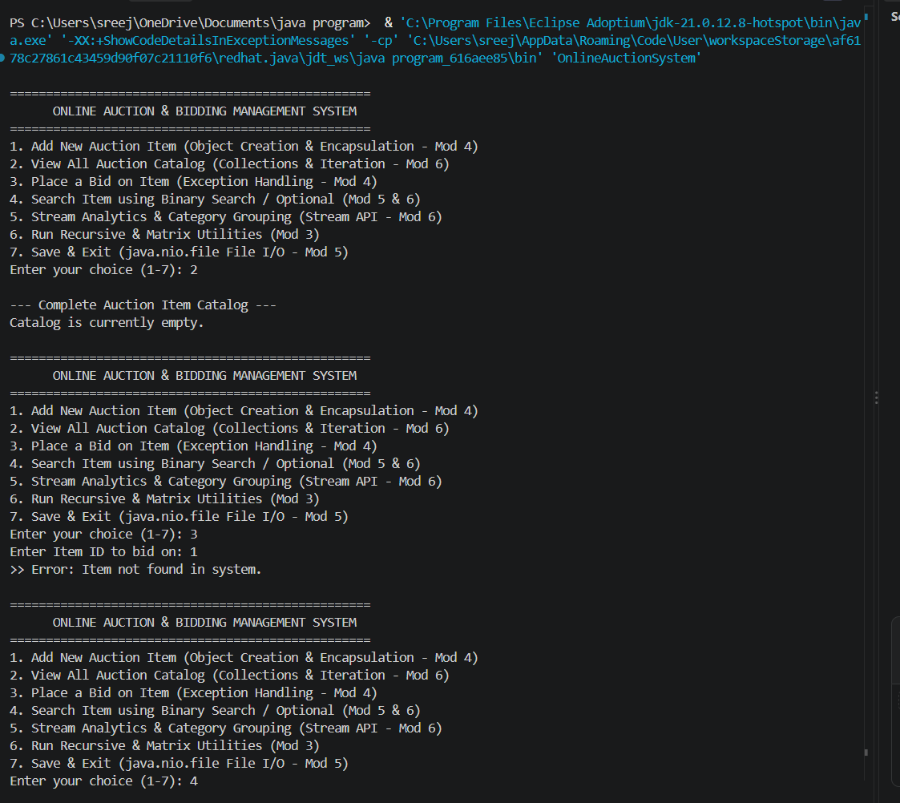
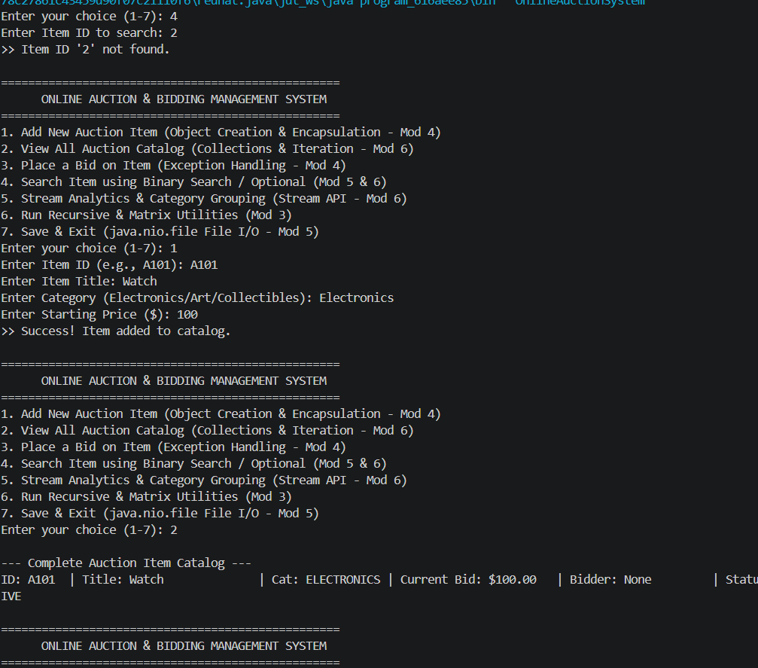
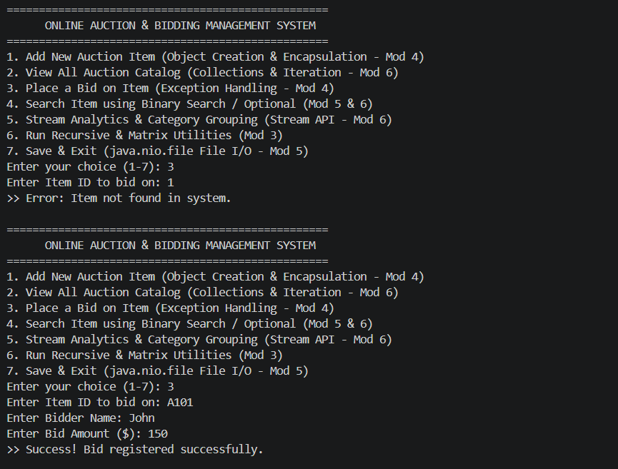
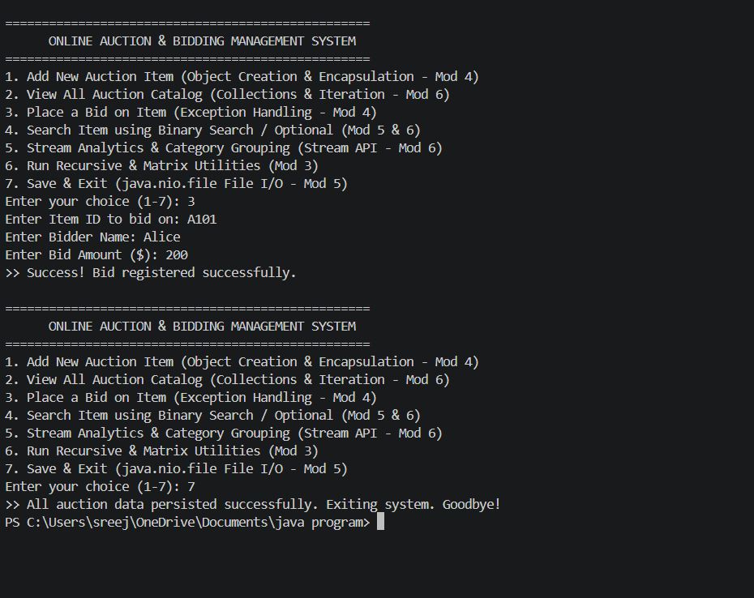
Conclusion
The Online Auction and Bidding System successfully translates real-world commercial auction requirements into a modular, highly efficient software application. By integrating fundamental control structures, recursion, object-oriented modeling, file-backed persistence, and modern functional programming features, the project bridges theoretical software engineering concepts with practical implementation. The resulting system provides a secure, reliable, and user-friendly platform for managing catalog items and bids, with strong potential for future scalability into web-based or distributed multi-user enterprise environments.

